Additional paper to Undergraduate Research Project made by Brinza Augustin Constantin on the theme of “Ethical use of AI in Education”.

This paper is made at requirements of Dr. Anastasios Liapakis with the purpose of understanding what the connection between my artifact and the URP theme and can be considered as an appendix to “Ethical use of AI in Education” made by Brinza Augustin Constantin, currently student of Computing (Application Development) at University of Bolton.

During my Project presentation, 2 problems have been raised: first being from the side of Dr. Anastasios Liapakis of how inexistent is the connection between my artifact and theme; second being addressed from the side of prof. Giorgos Prokopakis due to lack of understanding of what my artifact is doing.

Due to surpass of my 30 minutes required of presentation and the fact of answering same question multiple time, I was not able to satisfy the need of understanding of my supervisor vocally, fact that required an additional pepper where the connection of artifact and ethical use of ai in education must be related.

To be able to follow a good timeline of explanation - I will first solve, with a video, what my artifact is doing :

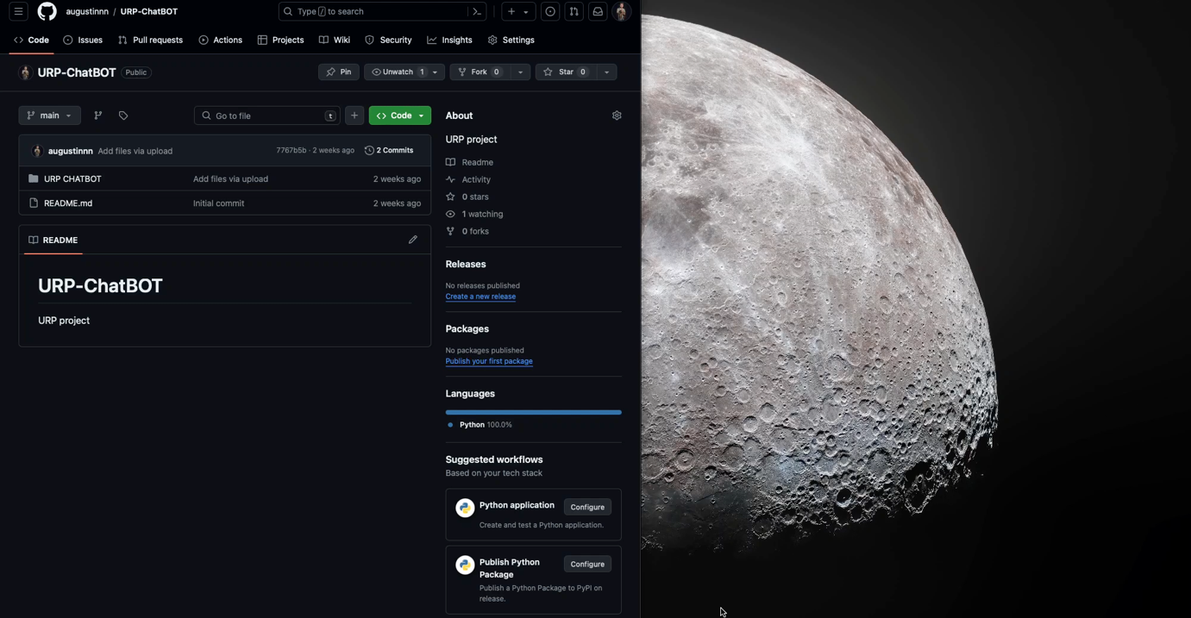

Video and code can be found in my Git repository at link: <https://github.com/augustinnn/URP-ChatBOT>

In order to solve second issue, due to requirements of more references, what being written into my presentation and project not being enough.

First, I would demonstrate how my artifact can be catalogate as AI.

Here is a passage – “For Primary and Secondary Education students, Artificial Intelligence (AI) tools offer a variety of idea, essay outlines and answers to question” from “Ethical Use of Artificial Intelligence and New Technologies in Education 5.0”, research conducted by : Zacharoula Smyrnaiou, Anna Bougia and Dr. Anastasios Liapakis, paper referenced by my after competition of URP, where an answering question program can be catalogate as an AI tool.

Second, I will show the field of where my artifact is taking information from.

Above is a list of questions that my artifact has the pre-written answers.

Mainly questions related with my research project theme “Ethical use of AI in Education.”. Questions are developed from my Undergraduate Research Project and have answers are adapted from it. My URP information is developed from sources as :

* <https://www.britannica.com/topic/ethics-philosophy/Anthropology-and-ethics>
* <https://ecampusontario.pressbooks.pub/ticl/chapter/6-1-educational-ethics/>

Third and last, while considering what are the educational principles : Justice, Utilitarianism, Deontology and Human Rights (conform Theories of Individual and Collective Learning, Chapter 6.1 Educational Ethics – from Open Library); according to society standards of fairness as an ethical principle of justice, my artifact can be catalogate as an ethical Ai tool, conform Dr. Anastasios Liapakis research referred above, due to its main purpose of responding to questions in this case related to my URP theme; from the perspective of utilitarianism principle , where the greater good for the greatest number must be satisfied, my artifact, if is developed on large scale or even like this for small mases, can deliver information for the part of society that do not have access to my research paper but can access my artifact; deontology principle can be catalogate as a requirement of meeting duties obligated by society, here as is also said into my URP, the data from where “URP ChatBOT” is taking his answers is created by me using information’s approved by society; Human Right – the only way of not being in concordance with this principle is to cross rights of human to live, be free, and pursue happies, none of this actions being performed and the whole purpose of my artifact can be seen as giving humans another way to intake quality information.

In my opinion, due to additional paper and with a 99% work of Undergraduate Research Project done by myself over the course of my last year as student of Computing at Bolton University that conferee me an obligation to defend my intellectual work, I can see where and how is contacted my artifact “URP ChatBOT” to my research theme “Ethical Use of AI in Education”, and also, on taking advantage of this additional paper, I want to apologies to my URP readers because of its lack on Harvard Reference style.